PROMISE & PRACTICE · DEEP DIVE · SOURCE ANALYSIS
Monitor vs. Virginia — A House Divided
The Day Wood Died
Name: ______________________________ Period: _____ Date: ________________
WHAT I CAN DO TODAY I can read primary sources about Monitor vs. Virginia — A House Divided, weigh who made each one and why, and use evidence to answer historical questions.
Directions. Some moments divide history into ‘before’ and ‘after.’ Compare the two, and explain exactly what changed

THE SOURCES
THE IMAGE · MARCH 1862 — Monitor vs. Virginia
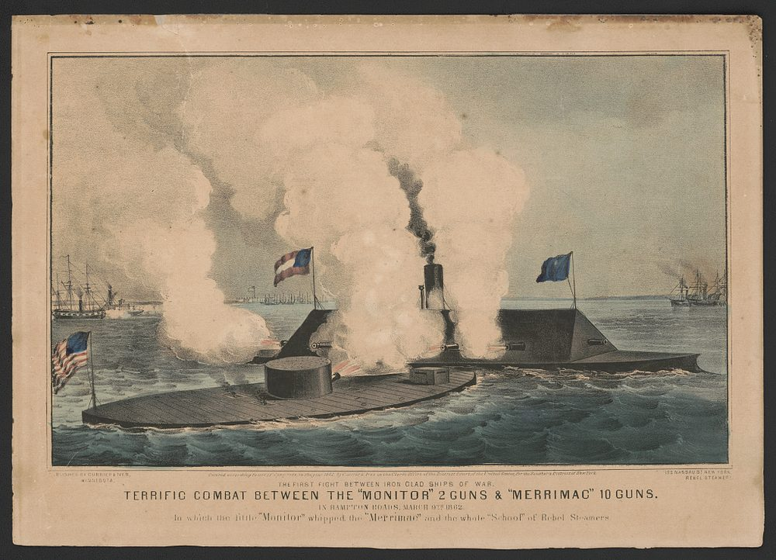
“Terrific Combat between the ‘Monitor’ and ‘Merrimac,’ Hampton Roads, March 9, 1862” — lithograph, Currier & Ives, 1862, public domain (Library of Congress).
THE IMAGE · JULY 1862 — The crew of the Monitor
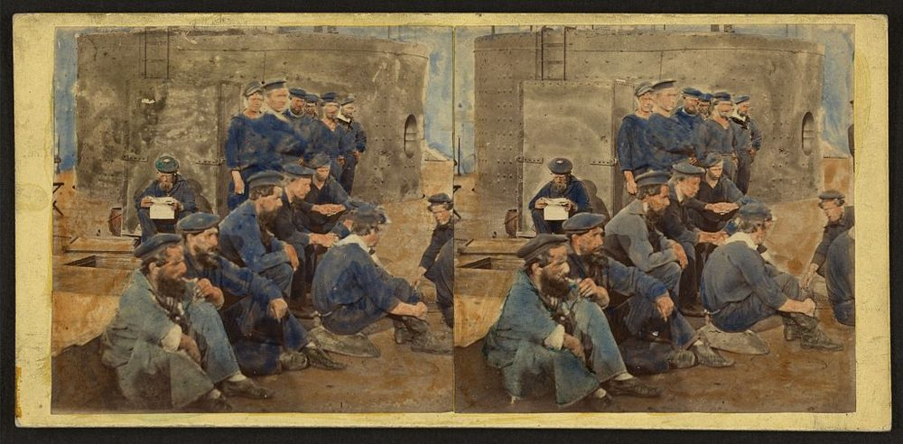
Low iron deck, a single turret, steam power, no sails. This is what a warship would look like for the next hundred years
Sailors on the deck of the U.S.S. Monitor, James River — hand-colored stereograph by James F. Gibson, July 1862, public domain (Library of Congress).
SOURCE · THE TIMES OF LONDON · 1862 — A naval superpower panics
“Whereas we had … one hundred and forty-nine first-class warships, we have now two. … There is not now a ship in the English navy … that it would not be madness to trust to an engagement with that little Monitor.”
— The Times of London, 1862. Public domain
— The Times of London, 1862. Public domain.

YOUR WORK
QUESTION 1 STEP 1 · BEFORE AND AFTER
In the chart, list the features of a warship before Hampton Roads and after it. Think about material, power, and how the guns aimed.
____________________________________________________________________________________________
____________________________________________________________________________________________
____________________________________________________________________________________________
QUESTION 2 STEP 2 · A DRAW THAT MATTERED
The battle ended in a draw — neither ironclad sank the other. Why do historians still call it one of the most important naval battles in history?
☐ A. because the Monitor sank the entire Confederate navy
☐ B. because it proved iron warships made every wooden navy in the world obsolete
☐ C. because it ended the Civil War
☐ D. because no one was watching
QUESTION 3 STEP 3 · THE RIPPLE
Britain had the most powerful navy on earth. Using the Times source, explain why a draw between two American ships would frighten London. What did Britain suddenly realize about its 149 warships?
____________________________________________________________________________________________
____________________________________________________________________________________________
____________________________________________________________________________________________
QUESTION 4 STEP 4 · WHY IT MATTERS
In two or three sentences, describe the change over time that Hampton Roads set off. What ended that day, what began, and why is March 9, 1862 a true turning point in world — not just American — history?
____________________________________________________________________________________________
____________________________________________________________________________________________
____________________________________________________________________________________________
____________________________________________________________________________________________
Promise & Practice · ShadowDog Digital Studios · Unit 2

TEACHER ANSWER KEY — Monitor vs. Virginia — A House Divided

QUESTION 1: Open response.
Look for a response along the lines of: “BEFORE: wood, sails, … | AFTER: iron, steam, rotating turret, …”
QUESTION 2: Correct — B. because it proved iron warships made every wooden navy in the world obsolete
Right. The outcome of the duel mattered less than its lesson: iron ships shrugged off fire that destroyed wooden ones. Every navy on earth had to start over.
QUESTION 3: Open response.
Look for a response along the lines of: “Britain realized its wooden fleet was now…”
QUESTION 4: Open response.
Look for a response along the lines of: “On March 9, 1862, ___ ended and ___ began. This mattered worldwide because…”

